**GOVERNMENT COLLEGE OF ENGINEERING [IRTT]**

**ERODE: 638 316**



**Electronics and Communication Engineering**

**NAAN MUDHALVAN**

**DIGITAL MARKETING**

**ASSIGNMENT**

NM ID: 9EB2C58A615645695A645D4582B753B0

NAME:MAHESHWARAN A

*BRAND NAME: MATTA*

*CATEGORY: BREWERIES*

1. Create a blog or website using Blogspot and WordPress. Customize the theme design and post new article with 500 words.

Link: Blog using Blogspot

<https://mattasaraku.blogspot.com/>

Screenshot:

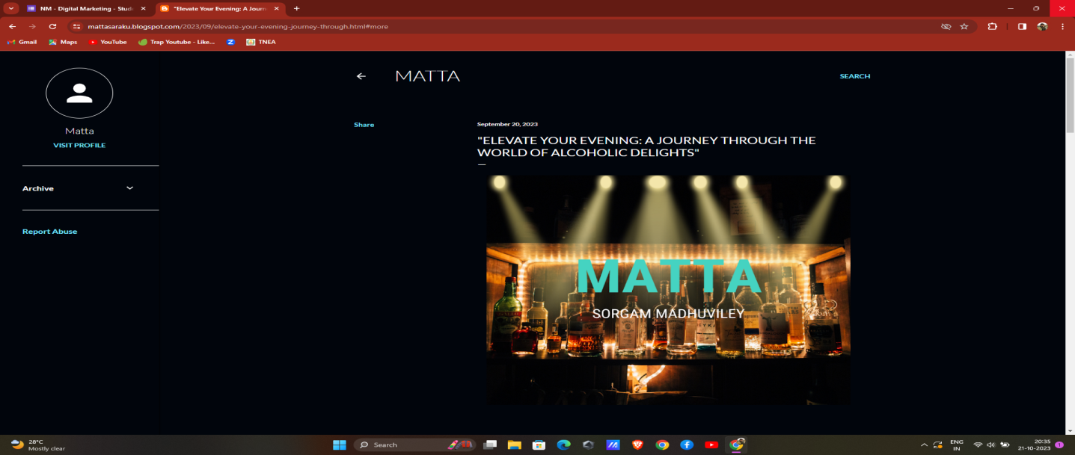

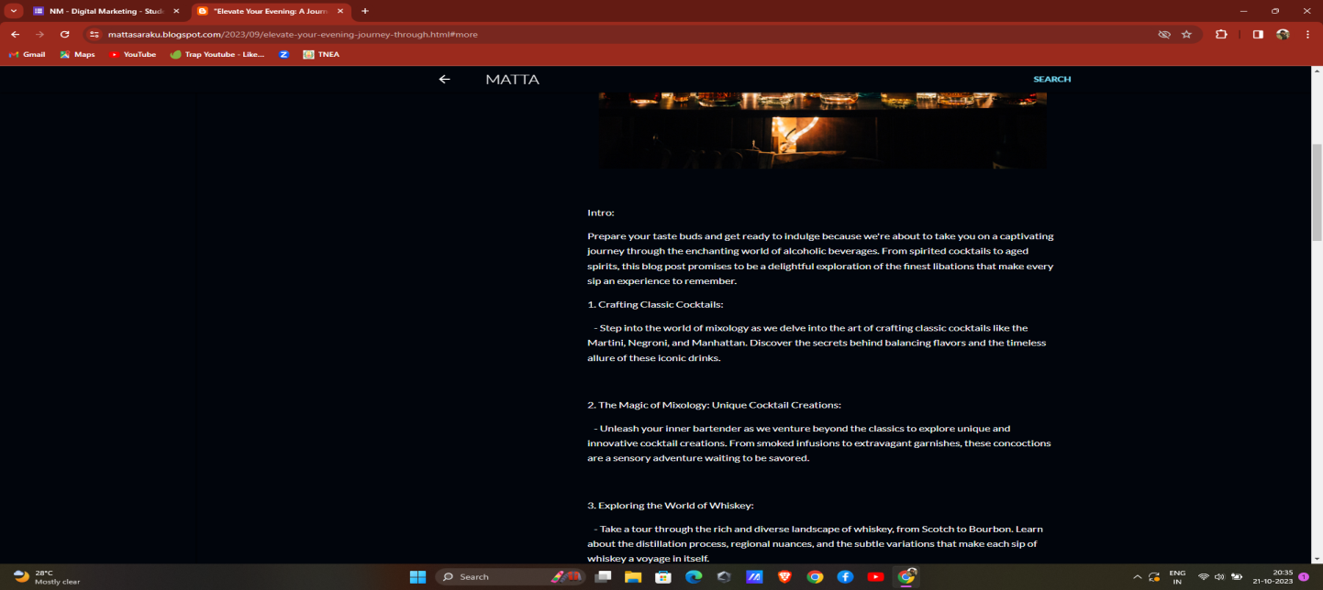

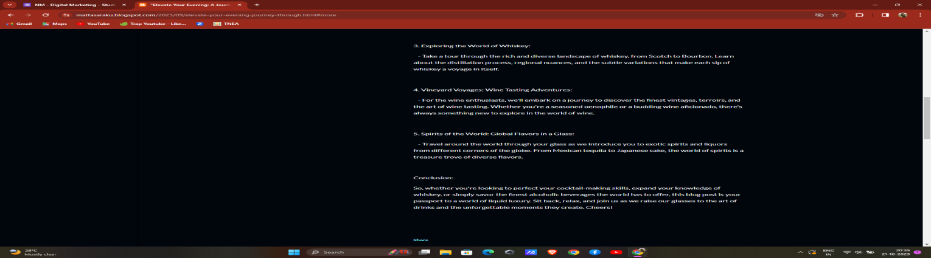

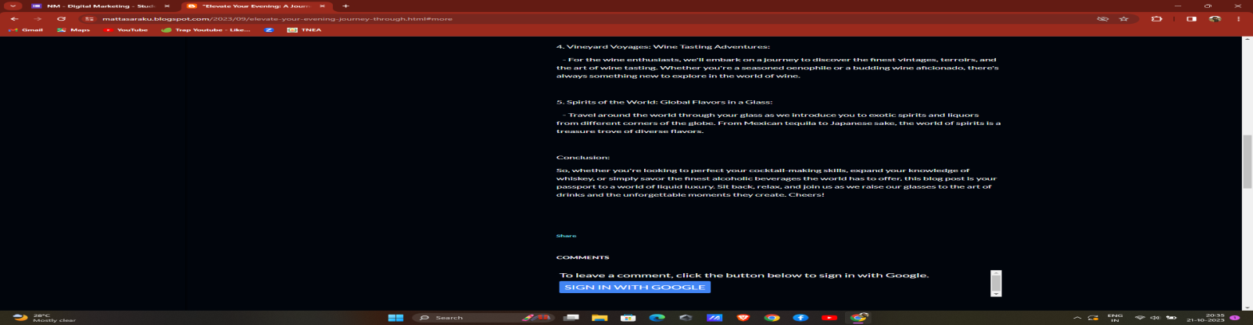

2.Create a New Facebook Business Page and post one social media poster for your brand.

Link: Facebook business page

<https://www.facebook.com/profile.php?id=61550620440368>

Screen shot: 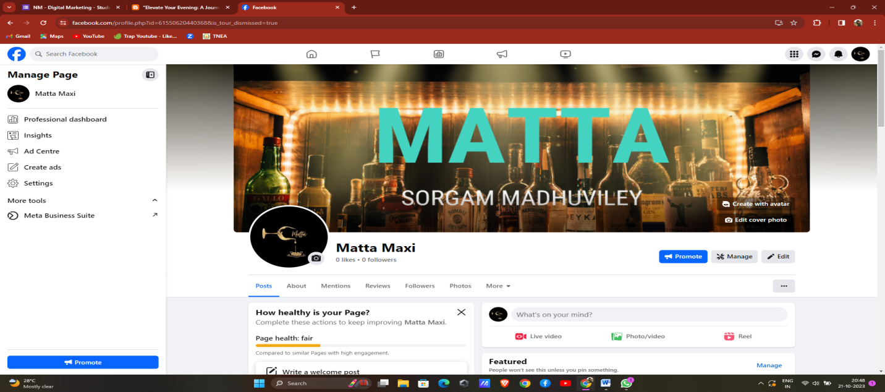

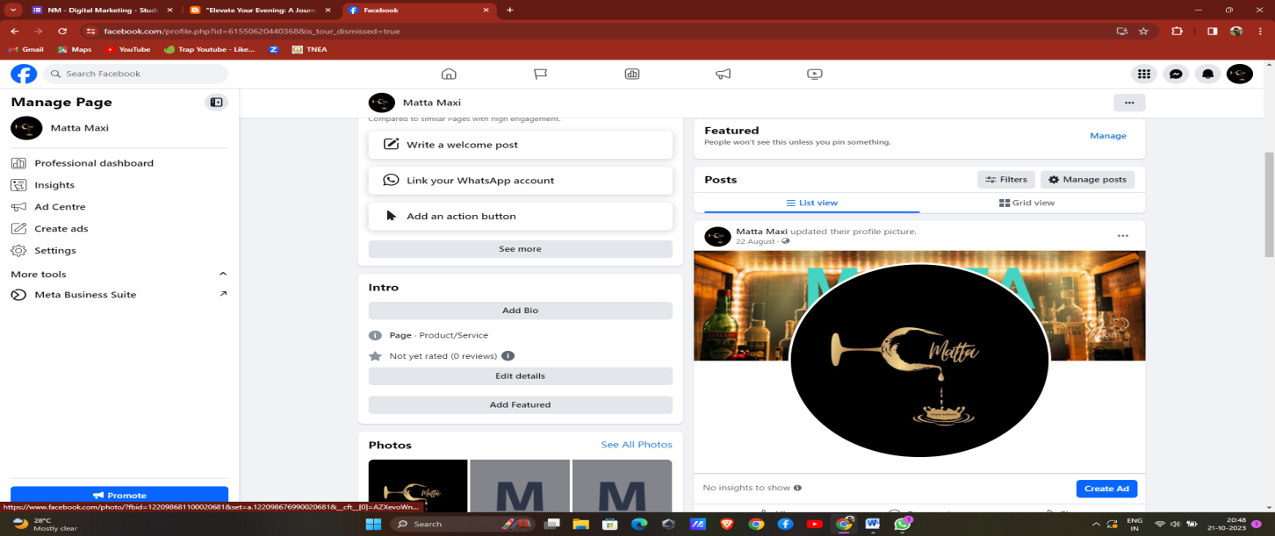

3.Create and design a social media advertisement poster using canva.

Link:

<https://mattasaraku.blogspot.com/2023/09/newsletter-grand-party.html>

Screenshot: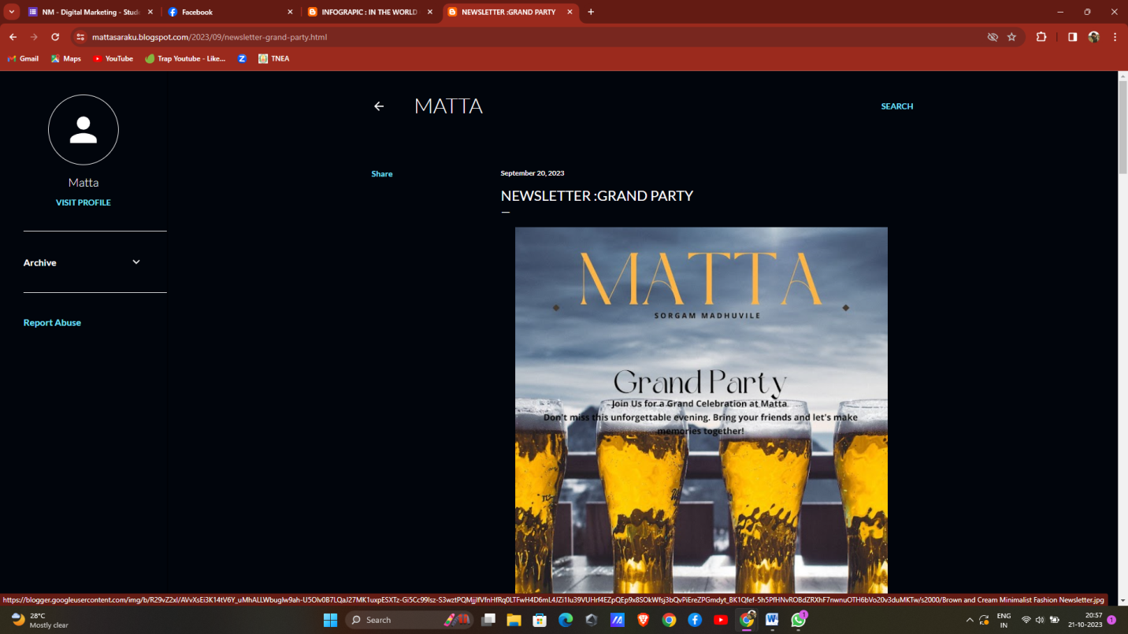

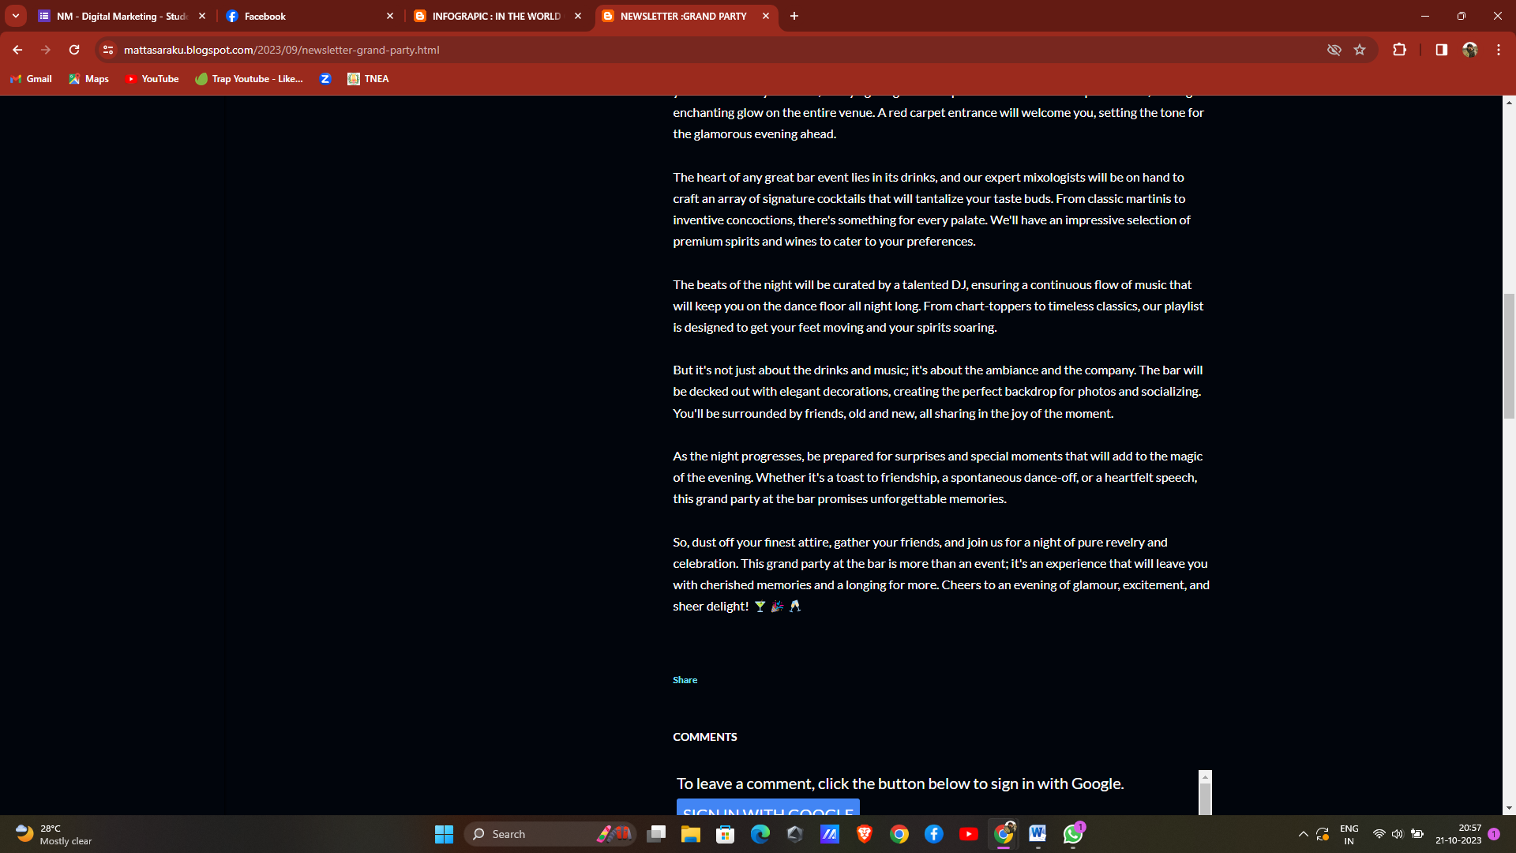

4.Create email newsletter design using MailChimp or canva tool.

Link: Email newsletter design using canva

<https://mattasaraku.blogspot.com/2023/09/in-world-of-matta.html>

screen shot:

